Name ___________________________ Week of August 29th
Weekly Star Activities
(3 times a week)
Recite alphabet (say not sing) Recite days of the week Recite Months Recite birthday
Rote Count 1 to 20 Recite full name Read a book with family (same book all week)
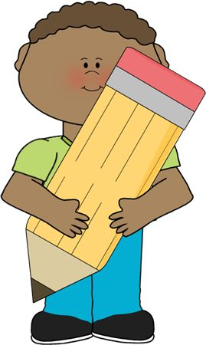
Check off every activity-completed daily and return all homework at the end of each week.
    - I traced and wrote my name
- I spelled and read each letter in my first name
- I can identify letters of the alphabet (flash cards)
- I worked on a language sheet

- I can identify objects in the kitchen (ask child to point to specific things in the kitchen. Next allow child to walk around and name objects).
- I can identify letters of the alphabet (flash cards)
- I worked on language sheet

- I recognized shapes and colors (flash cards)
- I can identify numbers 1 to 10 (flash cards)
- I can match objects to numbers. Show number 5 and have child count 5 objects.
- I worked on math sheet

- I traced and wrote my name
- I counted 10 forks and spoons
- I sorted into groups forks and spoons
- I worked on math sheet

